**O’Hare Project, Team C: Game Proposal Report**

Joshua Kidder (Team Lead)

Brian Schaeflein

Kellen Naughton

Courtney Maurer

William Jones

Joshua Corral

Aucoin Geter

DeVry University

Author Note

This paper was prepared for CEIS420

taught by Professor N. Liu

Game Proposal Report Week #: 8

**O’Hare Project, Team C: Game Proposal Report**

Prepared for:

Chicago Department of Aviation

Prepared by:

Team C

October 23, 2020

## 

[This Photo](https://courses.lumenlearning.com/technicalwriting/chapter/ethics-and-technical-communication-2/) by Unknown Author is licensed under [CC BY-SA](https://creativecommons.org/licenses/by-sa/4.0/)



[This Photo](https://courses.lumenlearning.com/technicalwriting/chapter/ethics-and-technical-communication-2/) by Unknown Author is licensed under [CC BY-SA](https://creativecommons.org/licenses/by-sa/4.0/)

MEMO

To: Chicago Department of Aviation

From: New Project Development, Team C

Date: October 23, 2020

Subject: Game Proposal Report

______________________________________________________________________________

Considering the request received, in partnership with the Chicago Department of Aviation, DeVry University’s IT-gaming students of the September 2020 O’Hare Project, Team C, has enclosed four game development proposals based upon the business needs of the client. The game development proposals enclosed include a total of four new games, two kid games and two adult games. The game proposals enclosed are:

* **Kids (ages range 4 -10):** Word Scramble & Algorithm Take Off
* **Adults (ages range 10+):** Puzzle of Puzzles & Sudoku

Team C is eager to meet with you to discuss any questions relating to any technical aspects of the

proposals, any questions regarding an administrative nature should be directed to the Professors of DeVry University. Your consideration is greatly appreciated.

Sincerely,

New Project Development, Team C

**Table of Contents**

Title Page……………………………………………………………………………………….....2

MEMO…………………………………………………………………………………………….3

Table of Contents………………………………………………………………………………….4

Executive Summary……………………………………………………………………………….7

Sudoku…………………………………………………………………………………………….8

Game Analysis…………………………………………………..…………..……8

Genre……………………………………………………..…………………..…...8

Platforms………………………………………………..……………………..….8

Target Audience…………………………………………………..…………..…..9

Game Play…………………………………………………..………………..…...9

Overview of Game Play……………………………………………….......9

Player Experience………………………………………………………..10

Flow Chart……………………………………………………………….10

Concept Art………………………………………………………………11

Puzzle of Puzzles………………………………………………………………………………...12

Game Analysis…………………………………………………..…………..…..12

Genre……………………………………………………..…………………..….12

Platforms………………………………………………..……………………….12

Target Audience…………………………………………………..…………..…13

Game Play…………………………………………………..………………..….13

Overview of Game Play……………………………………………….....13

Player Experience………………………………………………………..14

Flow Chart……………………………………………………………….15

Concept Art………………………………………………………………21

Word Scramble………………………………………………………………………………… .20

Game Analysis…………………………………………………..…………..…..20

Genre……………………………………………………..…………………..….20

Platforms………………………………………………..……………………….20

Target Audience…………………………………………………..…………..…21

Game Play…………………………………………………..………………..….21

Overview of Game Play……………………………………………….....21

Player Experience………………………………………………………..22

Flow Chart……………………………………………………………….23

Concept Art………………………………………………………………24

Algorithm Take Off….………………………………………………………………………… .27

Game Analysis…………………………………………………..…………..…..27

Genre……………………………………………………..…………………..….27

Platforms………………………………………………..……………………….27

Target Audience…………………………………………………..…………..…27

Game Play…………………………………………………..………………..….27

Overview of Game Play……………………………………………….....27

Player Experience………………………………………………………..28

Flow Chart……………………………………………………………….30

Concept Art………………………………………………………………31

**Executive Summary**

The Chicago Department of Aviation, along with O'Hare International Airport, have entered into a partnership with DeVry University in Chicago and talented IT-gaming students, to develop electronic games. Initially, the Chicago Department of Aviation requested for DeVry students to make mobile applications and games for passengers, however the scope of the project slightly changed, now requesting games that can be played within a browser on touchscreen kiosks throughout the O'Hare International Airport, with an emphasis on games geared towards children, ranging in ages from 4 to 10.

The Chicago Department of Aviation is wanting to help encourage travelers to walk around, explore, and visit local shops and restaurants throughout O'Hare International Airport, promoting the community locally and internationally, through the use of entertaining educational games, that will highlight the cultural and cosmopolitan experience of O'Hare International Airport, and its vast international network, while waiting on connecting flights.

Currently, DeVry IT-gaming students, have planned, designed, built, and maintained sixteen games for kiosks within O'Hare International Airport. As professionals we have a major investment in the client and the documents that are produced internally for our client relations, geared towards top quality documentation. Team C, of the September 2020 O'Hare Project has accepted this request, and are proposing four new games to potentially be selected from, for the kiosks at O'Hare International Airport: Word Scramble, Puzzle of Puzzles, Algorithm Take Off & Soduko.

Sudoku

william jones & brian schaeflein

**Game Analysis**

Sudoku is a highly popular mathematics game for people from all walks of life. It consists of players filling out a 9x9 grid that is broken up into 9 sections of 3x3. Each section is filled up with the numbers 1 through 9. The end result being to fill in every empty square with no rows or columns containing more than one of a given number. In some modes, after the timer runs out, the user will then be shown a score to determine how well they did. The user will have to use basic math and process of elimination to determine which numbers can properly fit in which squares as so of the squares will be filled from the start.

There will be two modes in this game, Classic and Time Trial. Classic Mode is the standard sudoku where the player has infinite time to finish and the only way to lose is to quit the game. The Second mode is Time Trial, this mode is very similar to classic, but a 5-minute clock is present from the start. The clock will Countdown and when it hits zero the game is done, and the player will receive a score based on how well they did. Since this is a game about numbers and mathematics I don’t see it having much of an airplane or airport theme in how it plays natively, but that does not mean that an airport or plane theme cannot be incorporated somewhere else.

**Genre**

Sudoku is a logic-mathematics game at its core. It tests the user’s ability to make decisions based off of given data, process of elimination, and recognizable patterns. As the player does the puzzles more, it will train the players brain to analyze numerical data more efficiently and even speed up the time it takes for their brains to run calculations.

**Platform**

The targeted platforms are the O'Hare International Airport Kiosks, within the Fly with Butch O'Hare Family Lounge located in Terminal 2 near Gate F2, along with smartphones, tablets, and laptops. The O'Hare International Kiosks will be our primary platform.

**Target Audience**

Sudoku’s targeted player audience will be adults ages 18 and higher. The game can be played by anyone of any age group though and is not gender specific. Due to the amount of patience, focus and analytical aptitude the game requires by nature I can see that this game would be more popular among an older audience.

**Gameplay**

**Overview of Gameplay**

Sudoku is an education mathematics themed puzzle-game that incorporates O’Hare International Airport. This game is intended to help players relax and polish their logic and mathematical skills. The targeted audience for this game is adults of any gender but can be played by younger people. The game is assessable through travelers on smartphones, tablets, and laptops by using an internet connection.

When a user selects Sudoku, they will be redirected to the main screen for Sudoku. This main screen will include the title of the game and the option to start the game. When the user selects the ‘Start Game’ option the user will be directed to the how to play screen which will state the rules and basic premise of the game. The user will then be prompted to choose the mode to play in, Classic or Time Trial. The Classic mode is more for players looking to relax and kill time. The time Trial mode is for those seeking more of a challenge, and if chosen the game will begin and a timer will appear on the screen counting down from 3. After the timer reaches one, Start will appear on the screen and the game will begin. Another timer will appear on the screen for 5 minutes that will count down to zero. A grid or 9x9 will appear and be broken up into 3x3 sections. Random squares in the grid will be filled in by number ranging from 1 through 9 totaling in up to 30% of the squares automatically filled. The user will get the user will then have 5 minutes to fill in all the remaining squares with the proper numbers. All 3x3 sections as well as all rows and columns must contain all the numbers 1 through 9 for the puzzle to be complete. If the timer reaches zero before the puzzle is complete the player will be scored based on the number or sections, columns and rows properly filled out.  They will get maximum points for completing the puzzle

**Player Experience**

The user will begin by accessing Sudoku through the Fly with Butch O’Hare Family Lounge Kiosk or through the application on their smart devices. Once the game is accessed, the user will be directed to the starting menu screen. This screen will display the game logo as well as a short description of the game. This is intended so the user knows what the game is about before beginning. The menu screen will also have a ‘Start Game’ button. After pressing the Start Game button, the user will be directed to the ‘How to Play’ screen which has instructions for how to play the game. This will have picture examples of what you will do in the game to help the intended younger audience know how to play the game. There will be another ‘Start Button’ located in the ‘How to Play’ screen which will direct the user to the mode selection.

After the user selects the desired mode, the game will begin. When the game is complete the user may or may not be shown a score. Afterwards the user will be given two options. The first is to restart the game and the other is to return to the menu. If they restart the game, they will be directed back to the mode select screen. If the choose the menu option, the user will be returned to the main menu.

**Flow Chart**

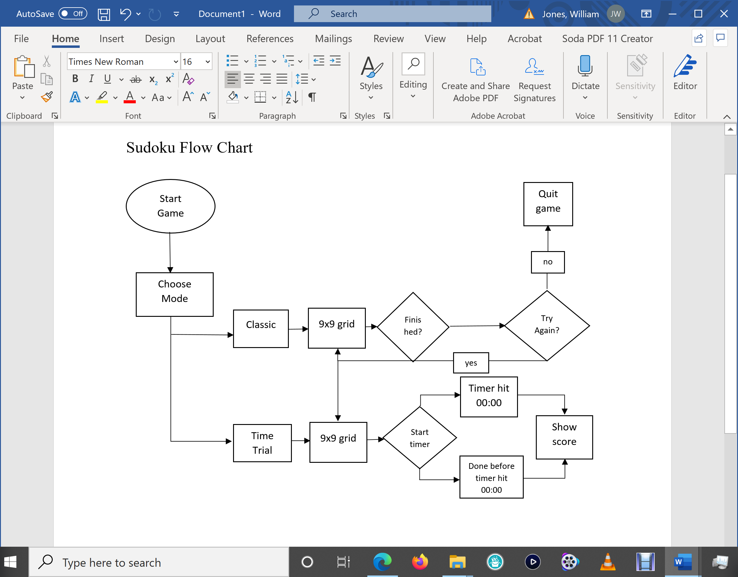

**Concept Art**

Examples of an unfinished and finished sudoku puzzle.

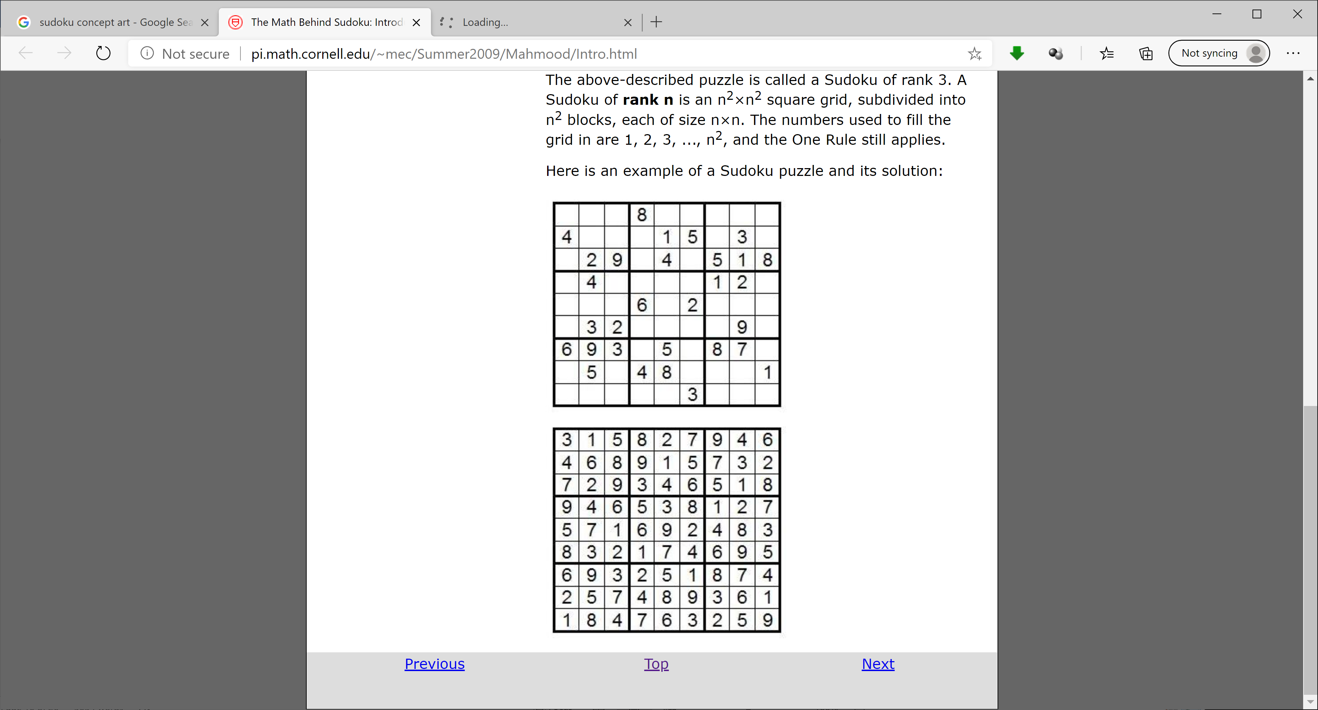 

Puzzle of Puzzles

joshua kidder

**Game Analysis**

Puzzle of Puzzles is a themed structured crossword puzzle, consisting of a number of long and short entries within a grid, featuring solid areas of white squares, and shaded squares. Every letter is checked, either as part of both an across word or a down word, and each answer must contain at least three letters. Clues are given, separated into an Across list and Down list. The grid may also be based upon a 180-degree rotational symmetry, so that its pattern appears the same if turned upside down. The puzzles appear in one of several standard sizes based upon the chosen difficulty level by the player.

This themed crossword puzzle, revolves around O'Hare International Airport, providing an entertaining educational puzzle game, focused on the cultural and cosmopolitan experience of leisurely travel, where you are able to learn fun filled facts about O'Hare International Airport. The game provides four different difficulty levels: Easy, Intermediate, Normal and Advanced, where a random puzzle will generate with clues, based upon specific areas within the airport, specific history about the airport, or specific aviation technologies. Along with themed images when a puzzle is completed, backstories if progressing between puzzle levels, and even a hidden word puzzle if all word puzzles are completed without exiting the game.

**Genre**

Puzzle of Puzzles is a hybrid type puzzle, consisting of both a logical and hidden object game, offering a series of related word puzzles, requiring the player to solve logic puzzles, testing many problem-solving skills including logic, pattern recognition, sequence solving, spatial recognition and word completion, based upon a single theme. Players must unravel a series of puzzles to advance to the next level, which in turn, leads to a more difficult challenge.

**Platform**

The targeted platforms are the O'Hare International Airport Kiosks, within the Fly with Butch O'Hare Family Lounge located in Terminal 2 near Gate F2, along with smartphones, tablets, and laptops. The O'Hare International Kiosks will be our primary platform.

**Target Audience**

We intend to attract a player audience from 10 years of age and older, aiming at both male and female travelers. We choose this, as the puzzles are to be educational, promoting O'Hare International Airport and its cultures, allowing the players to learn about new places, interests, and interesting facts, in an appeasing atmosphere, that will in turn, also draw-in a new customer base to surrounding restaurants, shops and stores within the Airport.

**Gameplay**

**Overview of Gameplay**

Puzzle of Puzzles is a themed hybrid crossword puzzle, that revolves around O'Hare International Airport, consisting of a logical and hidden object type puzzle game, containing a number of long and short entries within an auto-populated grid. Puzzle of Puzzles is targeted for a player audience of 10 years of age and older, aiming at both male and female travelers, and being accessible within the Fly with Butch O'Hare Family Lounge Kiosks, located in Terminal 2 near Gate F2; as well as, being accessible on travelers smartphones, tablets and laptops, through a standard internet connection.

Once a player selects Puzzle of Puzzles, the player will be redirected to an introduction screen, where the game is accessed by clicking on the Start Game option. Puzzle of Puzzles will then prompt the player to choose their preferred difficulty level. The difficulty levels available are Easy, Intermediate, Normal, and Advanced. As the difficulty level is chosen, an auto-populated crossword puzzle grid will load, with a clue list. The puzzles appear in one of several standard sizes based upon the chosen difficulty level by the player, ranging from 6x6 to 15x15 grids. There are a total of 5 Puzzles within each level, and a total of 21 Puzzle’s.

When a player completes a puzzle successfully, a hidden object picture will be displayed based upon the theme of the crossword puzzle, either educational or advertising based, and a backstory, while asked if they want to continue or exit the game. If a player completes all puzzles of a specified difficulty level, the player will then be asked if they want to continue on to the next level of difficulty. To unlock the hidden word puzzle, all difficulty levels must be completed in order, and without exiting the game, once completed the game is over.

**Player Experience**

You will begin by accessing Puzzle of Puzzles through the Fly with Butch O'Hare Family Lounge Kiosks. Once the puzzle game is accessed, a featured overview screen will display, giving a brief description of the game and a Start Game access button. Each of the word puzzle games are themed around O'Hare International Airport. After you start the game, you will then be able to choose which difficulty level you want to attempt. There are four difficulty levels to choose from, they are: Easy, Intermediate, Normal and Advanced. Each difficulty level consists of 5-word puzzles. Easy difficulty consists of auto-populated grid squares ranging from 6x6 to 8x8; Intermediate difficulty consists of auto-populated grid squares ranging from 9x9 to 11x11; Normal difficulty consists of auto-populated grid squares ranging from 12x12 to 14x14; and Advanced difficulty consists of auto-populated grid squares that are 15x15. As well as one hidden word puzzle to unlock, also consisting of auto-populated grid squares that are 15x15.

Upon entering the chosen difficulty level an auto-populated grid will appear, ranging from a 6x6 to 15x5 grid, depending upon the game difficulty, along with a clue list for that specific puzzle. The puzzle game is randomly selected out of the games for that specified difficulty level. Based upon the Across list and Down list, you will attempt to solve the word puzzle. Each letter entered, is checked against the correct answer. When a tile is entered, the validator will be triggered, turning the tile yellow. If the correct letter is given, the tile will turn green. If the letter is incorrect, the tile will remain white.

After an answer is successfully populated in either the Across list or Down list, the clue will be crossed out from the Across list or Down list. A single word puzzle is completed when all clues have been answered correctly. For example, if you completed a word puzzle that was restaurant themed, you'll receive a congratulatory message saying "High 5!, You completed Puzzle 1!", a themed image related to that specific restaurant, while also being asked if you want to Continue or Exit the game. If you Exit the game, you will not be able to pick up from your completed puzzle, meaning, the game will reset, and you will get the puzzle again if returning to the game. If you choose to Continue, the completed puzzle will be marked complete, and you will receive a newly auto-populated word puzzle for that difficulty level.

Once all word puzzles are completed for that difficulty level, you will get a new congratulatory message, for instance, saying "Puzzle Blitz!, You completed all 5 Puzzles!", "You just flew by with Butch O'Hare!", with a backstory of what you experienced, along with all the themed images in a cloud. You will also be asked if you want to Continue on to the next difficulty level or if you want to Exit the game. If you Exit the game, the game restarts, resetting all word puzzle difficulty levels. If you choose to continue, you will move into the next difficulty level. For instance, you complete all puzzles on difficulty Easy, when continuing you will move into difficulty Intermediate. With the completion of each difficulty level, a backstory will be provided.

In order to unlock the hidden word puzzle, you must complete all the word puzzles without exiting the game. The word puzzles must be completed in order, and once the Advanced difficulty level is completed, you'll receive a new message, for instance saying "Puzzle Crush!" with a back story, and the hidden word puzzle will unlock, being even more challenging, than the Advanced difficulty. Once, the hidden word puzzle is completed, you've completed the game, a new system message will display, for instance saying, "You're a Legend! You've been awarded the Butch O'Hare Commendation Puzzle Medal!".

**Flowchart**

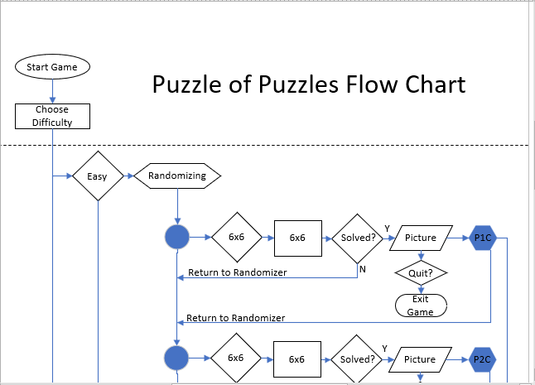

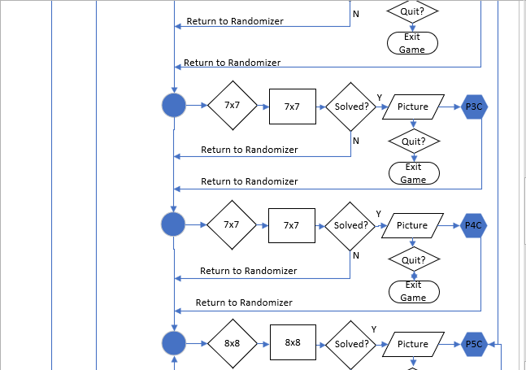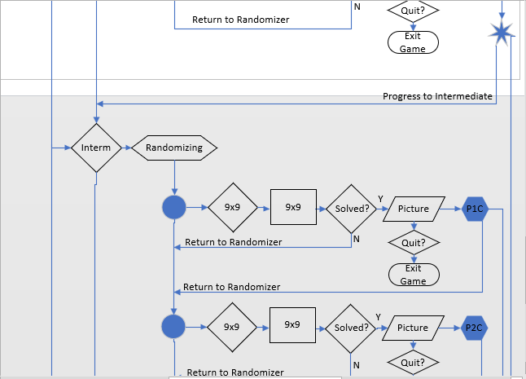

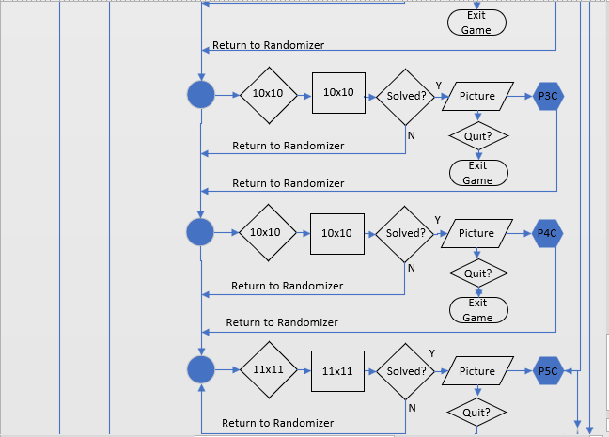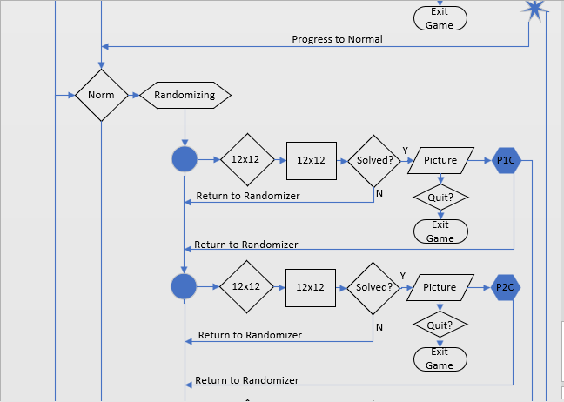

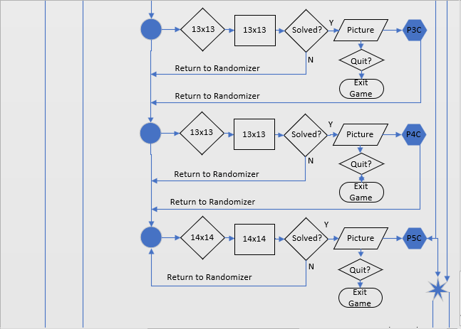

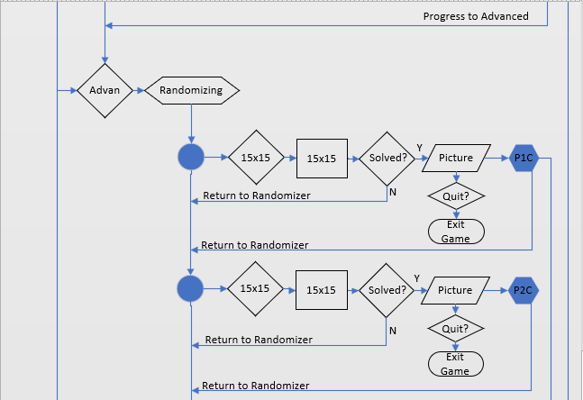

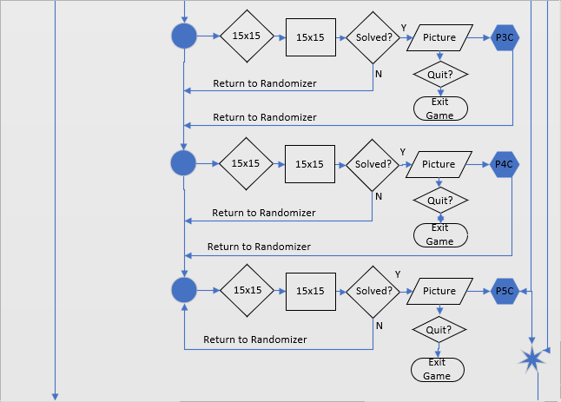

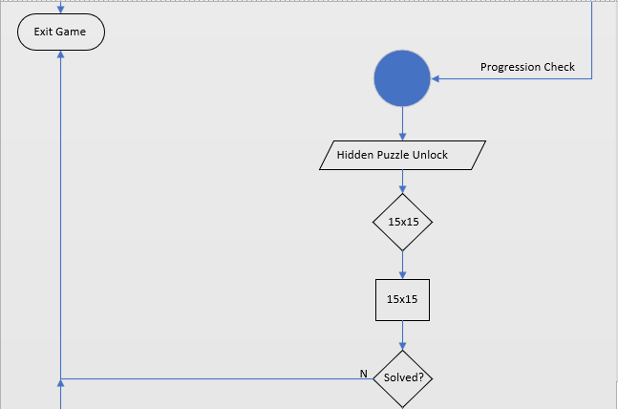

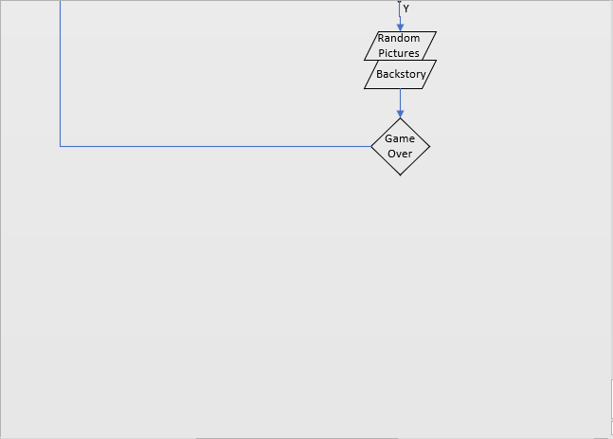

**Concept Art**

created in excel

**6 x 6 Style Grid 7 x 7 Style Grid**

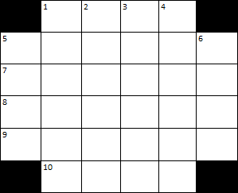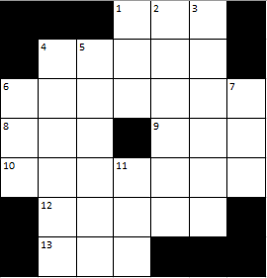

**11 x 11 Style Grid 15 x 15 Style Grid**

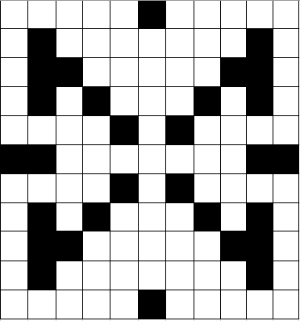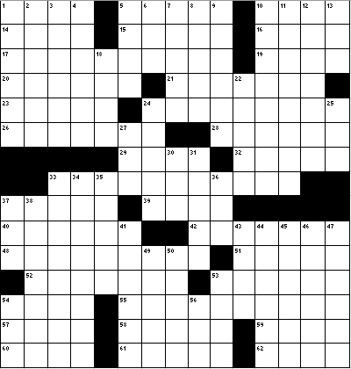

**Client Selection** Word Scrambler

(per professor) courtney maurer & aucoin geter

**Game Analysis**

Word Scrambler is a themed spelling practice game for children which consists of users having to pick a correctly spelt word out of a group of incorrect versions of the same word. The game will provide the user with the correct spelling of the word as long as an audio clip saying the word for a limited amount of time. After the timer runs out, the user will then be shown various spellings of the word on the screen. The user will have to sort through the spelling in order to select the correct spelling. This will help the user to be able to recognize the correctly spelt word while working on improving their individual spelling skill.

The theme of this spelling practice game will revolve around the O’Hare International Airport. The different words found in the game will be items that are focused on traveling, airports, or items from O’Hare International Airports sponsors that are kid friendly. This will allow the user to work on their spelling while also learning about the airport and traveling.

There will be three different levels in the game: Easy, Medium, Hard. These levels will have different words tailored towards different levels of spelling skill. The easier levels will have words with less letters and will be more common words that the user will be more familiar with. As the levels get harder, the words will become more complicated and words that are more unique. In hard mode the user will no longer be given the spelling of the word on the screen. Instead, the user will be played an audio clip of the word being said multiple times. The user will then be provided with one correct spelling in a group of misspelled versions of the same word.

**Genre**

Word Scrambler is an education puzzle game that focuses on increasing the users spelling skills. The user must use their previously acquired spelling skills to figure out the correct spelling of the word. As they continue to play the game and move through the harder levels, they will increase their familiarity with the words helping them to learn how to spell more words.

**Platform**

The targeted platforms are the O'Hare International Airport Kiosks, within the Fly with Butch O'Hare Family Lounge located in Terminal 2 near Gate F2, along with smartphones, tablets, and laptops. The O'Hare International Kiosks will be our primary platform.

**Target Audience**

Word Scrambler is target at a player audience of three years of age and older. This game is aimed at all genders of travelers. This game is focused on practicing spelling as well as learning different types of words relating to O’Hare International Airport, traveling, and sponsored items that can be found in the airport.

**Gameplay**

**Overview of Gameplay**

Word Scrambler is an education puzzle themed game that incorporates O’Hare International Airport. This game is intended to teach younger users’ new words and how to spell these words. The targeted audience for this game is three years of age and older and is aimed at all genders. The game is assessable through travelers on smartphones, tablets, and laptops by using an internet connection.

When a user selects Word Scrambler, they will be redirected to the main screen for Word Scrambler. This main screen will include the title of the game and the option to start the game. When the user selects the ‘Start Game’ option the user will be directed to the how to play screen. This screen will display the basic rules for the games. This ‘How To’ page will have written descriptions as well as picture snippets from the game to help further explain the game. The user will then be prompted to choose their preferred difficulty level. The difficulty levels available in the game are easy, medium, and hard. As the difficulty is chosen, the game will begin. A timer will appear on the screen counting down from three. After the timer reaches one, Start will appear on the screen and the game will begin. Depending on the level chosen, the game will either show the word with an audio of the word being pronounced, just the word with no audio, or just the audio of the word being pronounced with no shown correct spelling of the word. The user will get ten seconds to study the word or the audio que. After the ten seconds, the user will then be shown different spellings of the word with only one being correct. They player will then have to select the correctly spelt word. If they end up selecting the wrong version of the word, they will be notified that that is incorrect and that spelling of the word will disappear from the screen and not be able to be chosen again. When the correct word is selected the user will be told that they have selected the correct word. They will then be provided the spelling and audio for the correct word again as well as a picture of the word and a brief description. This will be repeated with five randomly generated words for each of the levels.

When the level is completed, the user will be shown all five words spelt correctly again. They will also be provided the picture and a brief description. This is intended for the user to gain recognition of the word as well as learn what the word means. They will then be prompted with two options. The first is to restart the game and the other is to return to the menu. If they restart the game, they will be directed back to the level select. If the choose the menu option, the user will be returned to the main menu.

**Player Experience**

The user will begin by accessing Word Scrambler through the Fly with Butch O’Hare Family Lounge Kiosk or through the application on their smart devices. Once the game is accessed, the user will be directed to the starting menu screen. This screen will display the game logo as well as a short description of the game. This is intended so the user knows what the game is about before beginning. The menu screen will also have a ‘Start Game’ button. After pressing the Start Game button, the user will be directed to the ‘How to Play’ screen which has instructions for how to play the game. This will have picture examples of what you will do in the game to help the intended younger audience know how to play the game. There will be another ‘Start Button’ located in the ‘How to Play’ screen which will direct the user to the difficulty select.

There are three difficulties to choose from: Easy, Medium, and Hard. The Easy difficulty will provide the user with the correct spelling of the word as well as an audio clip of the word being said. The correct spelling of the word will remain on the screen for ten seconds and the audio will repeat periodically during these ten seconds. In Medium mode, the user will only be provided the correct spelling of the word for ten seconds. There will not be the audio que of the word. For hard mode, the user will only be provided the audio of the word for ten seconds. They will not be provided with the correct spelling of the word. A description of each level will be provided next to the difficulty.

After the user selects the desired difficulty, the game will begin. Depending on the selected difficulty, the user will either be prompted with the audio que of the word and/or the displayed correct spelling of the word. A timer will begin for ten seconds. After ten seconds, the correctly spelt word will disappear, and the audio que will stop. The screen will then show different spelling of the word that was provided earlier. Only one of the words shown on the screen will be the correct spelling of the word and the others will be incorrectly spelt. The user will have to choose the correctly spelt word. If the user selects an option that is incorrect, a popup will appear stating that the user has picked the incorrect spelling of the word and to try again. The popup and the incorrectly selected word will then disappear, and the user will choose again. This will repeat until the user selects the correct word. When the correct word is selected, the user will be directed to a screen that states in big letter “You have selected the correct spelling of the word”. You will then see the word spelt correctly and a picture of what the word is. You will also be provided a brief description of the word. This will be repeated five times per level.

When the level is completed, the user will be shown all five words spelt correctly again. They will also be provided the picture and a brief description. This is intended for the user to gain recognition of the word as well as learn what the word means. They will then be prompted with two options. The first is to restart the game and the other is to return to the menu. If they restart the game, they will be directed back to the level select. If the choose the menu option, the user will be returned to the main menu.

**Flow Chart**

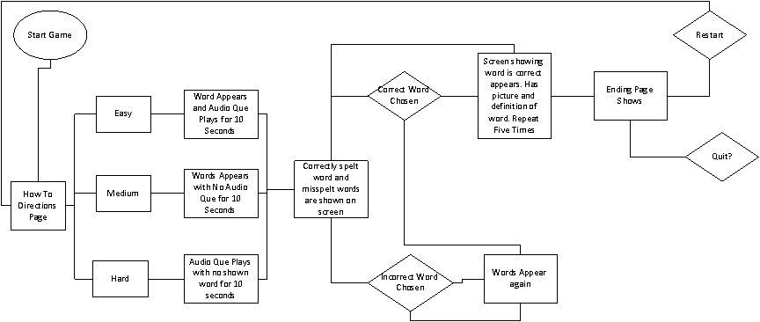

**Concept Art**

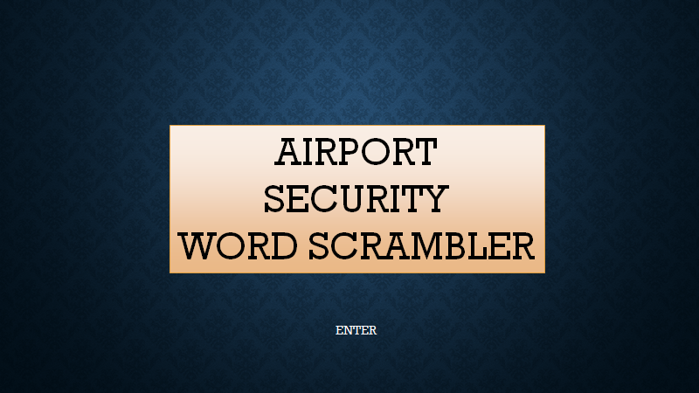

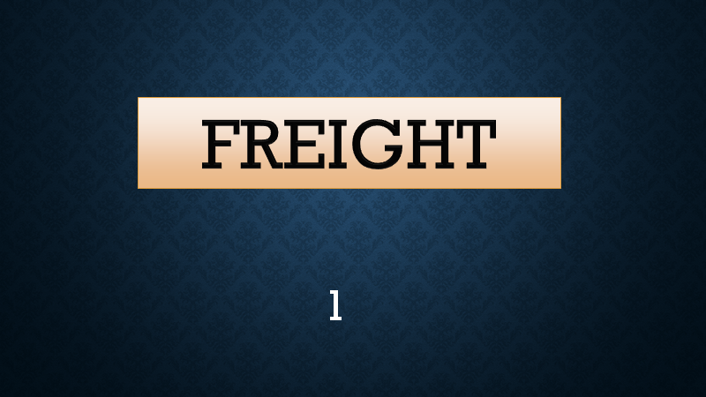

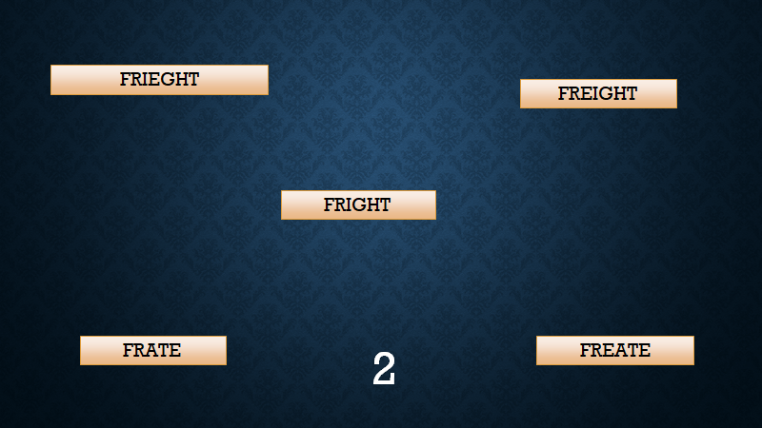

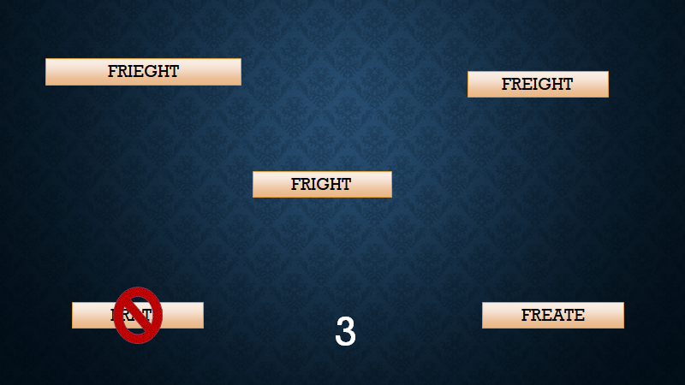

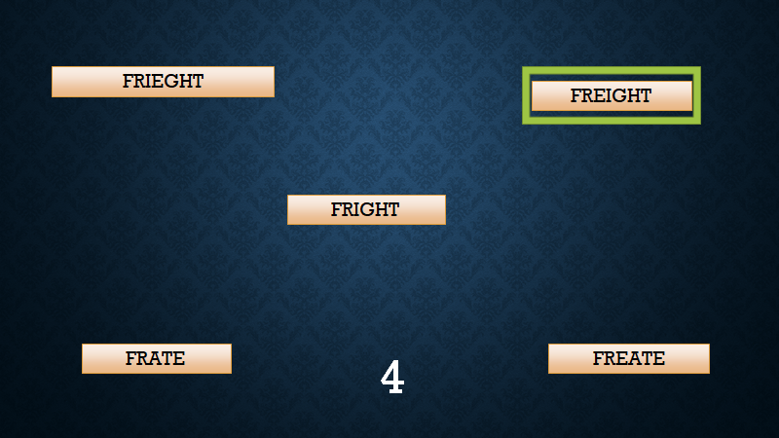

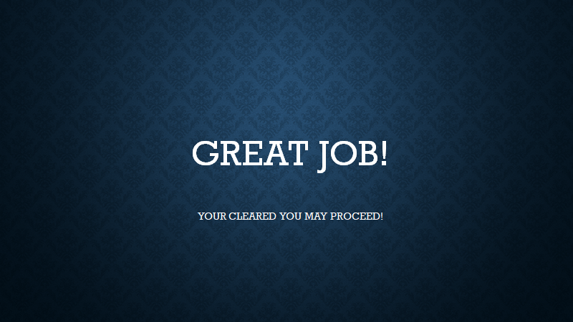

Algorithm Take-Off

joshua corral & kellen naughton

**Game Analysis**

The player must select the correct sequence of numbers in order for the airplane to successfully take-off. The game displays a plane on the runway on the left side of the screen, that is not yet moving, along with colored numbers sequencing from 3 through 0 and are separate from each other around the screen. Players must choose the correct sequence of the given numbers in order for the airplane to take-off. To do this, the players are responsible for choosing which of the four numbers, ranging from 3 through 0, to choose from first and last. Once the numbers are chosen correctly, we countdown “3... 2... 1... 0... Take-off!” and the airplane then makes its animations down the runway towards take-off.

**Genre**

A puzzle game for kids that aims to improve their skills with numbers.

**Platform**

The targeted platforms are the O'Hare International Airport Kiosks, within the Fly with Butch O'Hare Family Lounge located in Terminal 2 near Gate F2, along with smartphones, tablets, and laptops. The O'Hare International Kiosks will be our primary platform.

**Target Audience**

We intend to attract a player audience from 10 years of age and younger, aiming at both male and female travelers. We choose this, as the puzzles are to be educational, promoting O'Hare International Airport and its cultures, allowing the players to learn about new places, interests, and interesting facts, in an appeasing atmosphere, that will in turn, also draw-in a new customer base to surrounding restaurants, shops and stores within the Airport.

**Gameplay**

**Overview of Gameplay**

To play, the player chooses from the given options of numbers on the screen. Every number that is on the screen will also be identified with a specific color to match a color bubble on the bottom of the screen where a tray resides that holds the numbers selected. Next to the bubble tray, a take-off button resides where the player will press once they are done choosing from the given numbers and an announcer will start a countdown. Whenever the player chooses the wrong number that is next in the sequence, an announcer will tell them the number and say that whatever they chose was the wrong one. Moreover, whenever the player hovers over a number that is given, an announcer says the number to inform the player what they are about to choose. As the player continues to complete a couple levels, every level after becomes harder by adding more numbers. For instance, after finishing two rounds of choosing from 3, 2, 1, and 0, then the options become increased to the number 5. For each additional number, there will also be more color options for both the number and the blank bubble tray at the bottom of the screen.

**Player Experience**

Players cannot lose in this game however, in order for the airplane to successfully take-off, the players must correctly choose the right sequence of numbers. Furthermore, players experience a game where they are able to develop their basic skills of counting in order to allow the airplane to take-off.

**Flowchart**

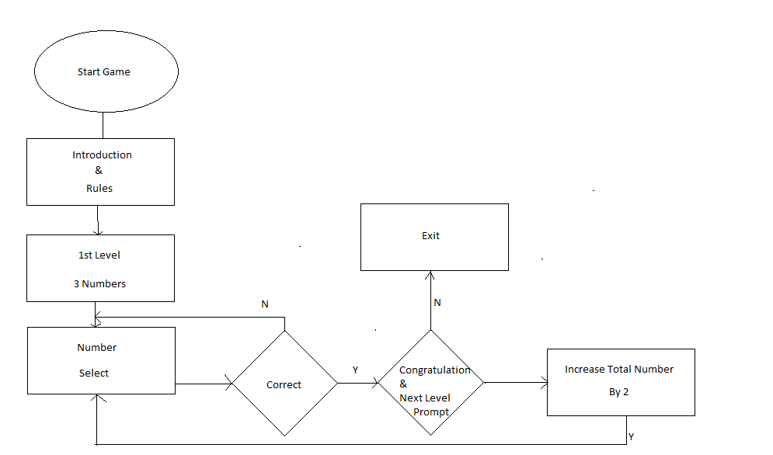

**Concept Art**

